Workshops –see website for complete info – full day workshops are Thursday and ½ day workshops are Friday following Guild meeting and trunk show. Registration & fee required. Registration forms are online – or contact Sandy Jung – sconradj@gmail.com 518/469-3960
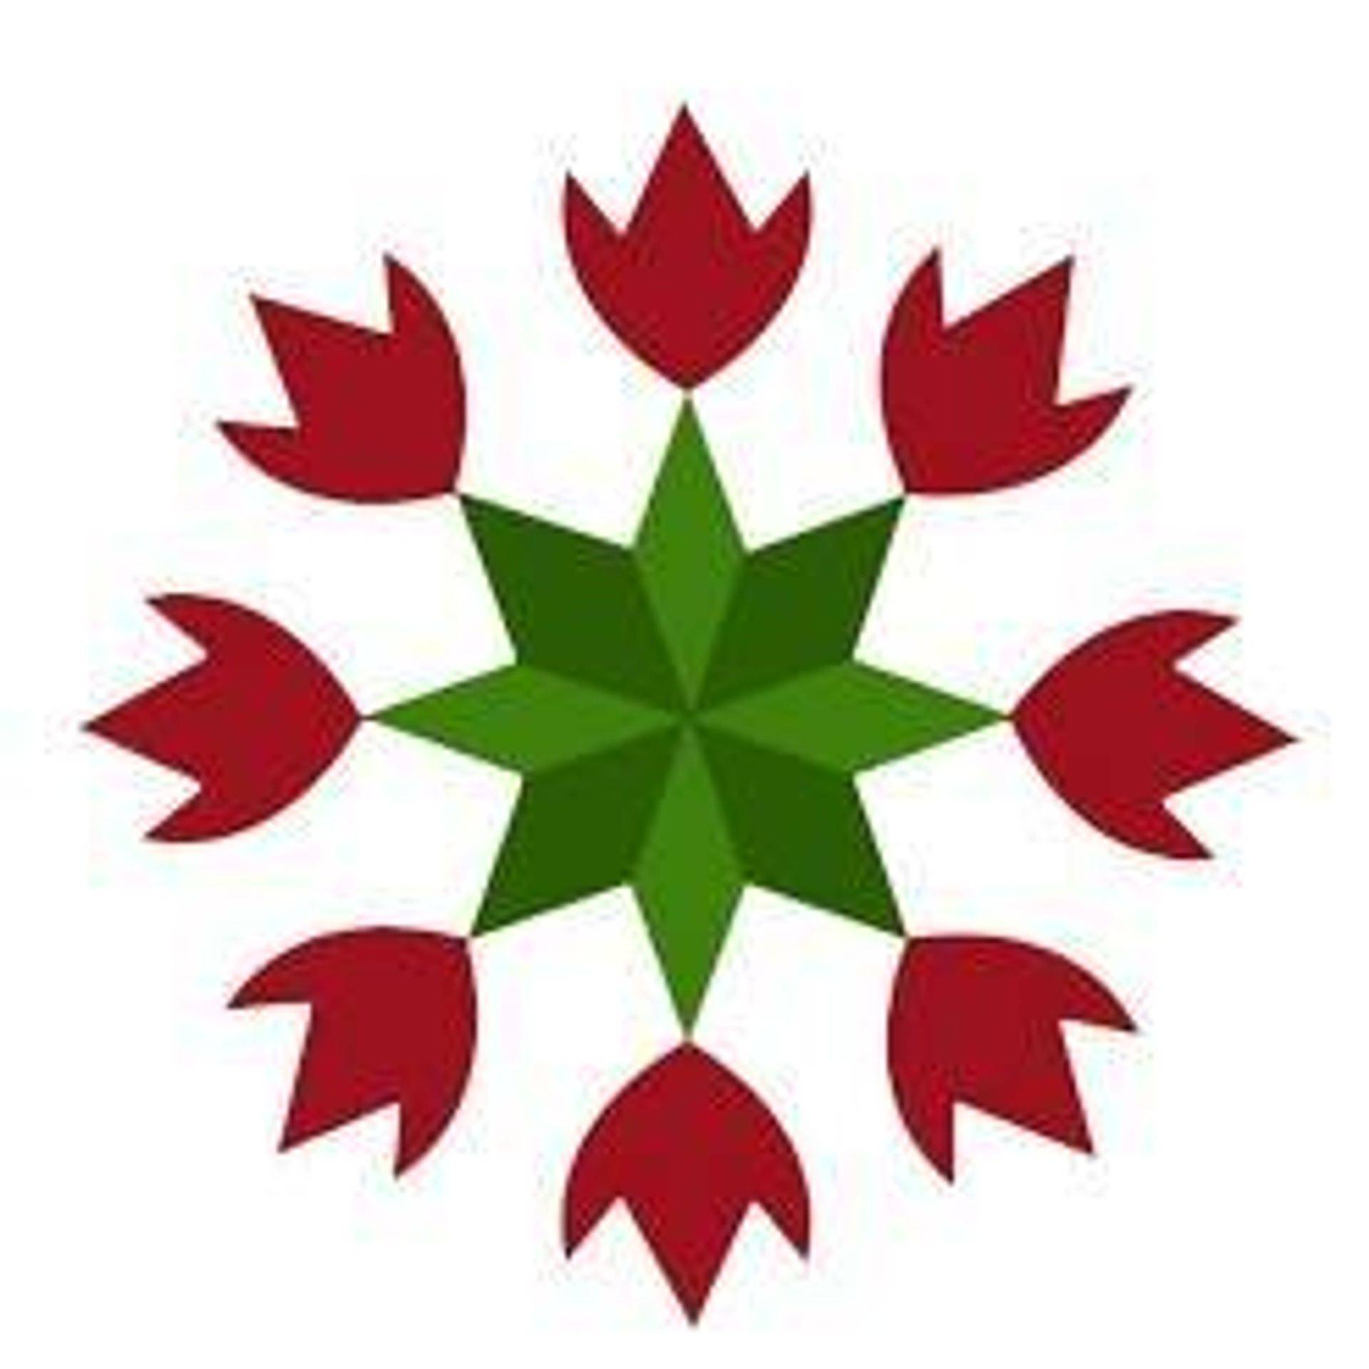Quilters United in Learning Together
Delmar Reformed Church, 386 Delaware Ave., Delmar, NY 12054
https://www.quiltinc.org/workshop-information

Non-members are welcome and will be wait-listed until one month prior to workshop date; emails will be sent to confirm your seat in the class. Join the Delmar QUILT Guild and register early to assure a spot!
----------------------------------------------------------------------------
April 16, 9:30-3:30 --- Amy Friend “Magic Spark - Intentional Large-Scale Paper Piecing” https://duringquiettime.com/ $60 member /$70 non-member ( + $10 for pattern - pay Amy at class)

Magic Spark serves as a great introduction to modern, large scale paper piecing. Paper piecing with larger pieces of fabric is in many ways more difficult than paper piecing with small pieces that are more easily handled. Learn some new tricks to make large scale paper piecing work while also learning to place your fabric intentionally to enhance the pattern design. Explore various layouts for a unique quilt top.

April 17, 12:30-3:30 – “Modern Selvage Quilts – Whirlwind” $35 member / $45 non-member
Have you been saving those precious selvages for ages but aren’t quite sure what to do with them? Selvage Whirlwind is a fun modern quilt that make use of a wide range of colored selvages from your collection. Learn how best to collect selvages, what makes a selvage design work, and create several selvage blocks sharing selvages with your classmates so you have a wide range of colors.
May 7, 9:30-3:30 - Sheri Cifaldi-Morrill “Hawaiian Inspired Appliqué” $60 member /$70 non-member
Learn how to make the Big Island Blossom block, a modern interpretation of traditional Hawaiian quilts. In this workshop, you will learn how to prepare the applique (including folding, cutting and basting) and how to apply the motif using needle-turn applique techniques. Learn how Sheri designed the block and how you can design your own templates for future projects. We’ll also review quilting tips and traditional Hawaiian quilting resources. By the end of class, students will have most of the block (finished size: 32” x 32”) basted and will start practicing needle-turn applique. This is a full day handwork class – leave your machine home

May 8, 12:30-3:30 - Sheri Cifaldi-Morrill “Dragonfly Dance” $35+ member / $45+ non-member
Improve your paper piecing skills by making the Dragonfly Dance quilt. Sheri will walk you through all of the steps while demonstrating tips and tricks for staying organized, working efficiently and achieving precise alignments. We’ll also review finishing the quilt top and quilting tips. This workshop is geared towards the confident beginner / intermediate foundation paper piecer (previous foundation paper piecing experience recommended). By the end of class, most students will have some of the dragonflies complete and will have started to piece them together. + Each registered student needs to purchase the Dragonfly Dance quilt pattern ($12) online (shop.wholecirclestudio.com ) prior to class in order to complete light prep work, including fabric selection.

Sheri can be contacted with any questions - email: sheri@wholecirclestudio.com I look forward to working with you!

