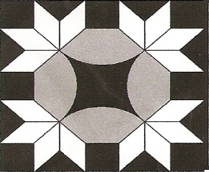 **WILTWYCK QUILTERS’**

**GUILD NEWSLETTER**

**wiltwyckquilters.org March 2015 Volume 38 Issue 7**

**NEXT GUILD MEETING**

# 

**Saturday, March 21, 2015**

**GRACE COMMUNITY CHURCH**

**160 SEREMMA CT.**

**LAKE KATRINE, NY 12449**

**9:30 – 10:00 for coffee,**

**Tea and snacks**

Items to bring to the March meeting:

* Name Tag (wear it and get a raffle ticket)
* Show and tell items
* Quilts for appraisals by Sue Reich (see fee schedule below

**TREATS**

All members are asked to bring a snack to the monthly meeting. The Hospitality schedule for the year is as follows, according to the first letter of your last name.

**March G, H**; April J, K, L; May M, N, O; June P, Q, I.

**PRESIDENT’S MESSAGE**

Believe it or not spring is just around the corner!

Our short February meeting enabled us to have the workshops before the snow started.  
I would like to thank the members that attended the workshops, and the instructors, Dolly Wodin, Dagmar Yaddow and Shirley Swenson.  
 THANK YOU!!  
  
Looking forward to March with NO Snow!!

**Anita**

|  |  |  |  |
| --- | --- | --- | --- |
| **Board Meetings** | **Quilt show Meetings** | **Regular Meetings** | **Community Meetings** |
| Mar. 15 |  | Mar. 21 | Mar. 25 |
|  | Apr. 12 | Apr. 18 | Apr. 22 |
| *May 3 |  | May 16 | May 20 |
|  | *June 7 | June 20 | June 24 |

All WQG meetings are held at the Grace Community Church. The coffee hour begins at 9:30. The meeting begin at 10:00.

Board meetings are held at the Ulster Town Hall on Sundays at 2:00. All board and committee members should attend these meetings. ALL members of the guild are welcomed to attend these meetings. Meeting time and date are subject to change.



**President Anita Rowell**

**Vice President Dagmar Yaddow**

**Recording Sec. Alice Maceyak**

**Corresponding Sec. Deidre Thorpe-Clark**

**Treasurer Pat Williams**

**Parliamentarian Joyce Luby**

**Committee Heads**

**Past President Lesley Gray**

**Community Service Anita Rowell**

**Historian Leona Willis**

**Hospitality Theresa Pabon/Peg Smith**

**Librarian Mary McLaughlin**

**\*Membership Gloria Frenza**

**Newsletter Peggy Smith**

**\*Program Shirley Swenson/Kim Warren**

**Publicity Jackie Sittner**

**\*Quilt Show Angee Opkyke**

**Raffle Table Regina Packard**

**Web Master Lynne Davidson**

**\*Voting Committee Members**

**The Wiltwyck Quilters’ Guild is a non-profit organization. The purpose of this organization shall be to preserve the tradition and the history of quilt making, as well as to foster awareness and receptivity to create innovation in the art, to promote and sponsor interest and appreciation in all areas of quilt making among our members and the general public, and to promulgate friendship and the exchange of ideas.**

**COMMUNITY SERVICE**

When planning your quilt for the shelter think *children* please use batting and either tie or machine quilt.  And if you want, please put a red heart on it!  
For the nursing home: please plan for an adult, both female and male. NO Batting NO heart!!! Just a top and a backing.  Lite weight corduroy or flannel.  The size should be about 36-38" wide and about 48" long.  Not too wide as they can get caught in the wheelchair wheels  
 Community service sewing is the Wednesday AFTER the regular meeting. Community service sewing is held at the Kingston Elks Lodge, 143 Hurley Ave., Kingston, at 9:00 until noon.

**Thanks, Anita Rowell**

**Membership**

Wear your name tag to receive a free raffle ticket.

**Upcoming Events**

* March 21 – Lecture, trunk show, and quilt appraisals by Sue Reich
* April 17 – “NY Beauty Diversified workshop” with Linda Hahn
* April 18 – “Stashbasher” lecture/trunk show and “Junk to Jems” workshop with Linda Hahn
* May 16, 2015 –To be determined, possibly community service sewing
* June 20, 2015 – Jacquie Atkins, ‎Curatorial Consultant/Textile Historian

Shirley Swenson

**Quilt Historian and Appraiser Sue Reich**

“If you are passionate about what you do, you’ll never have to work a day in your life! For me, that passion is the study of quilt history.”

Sue Reich

Sue Reich of Washington Depot, CT., first learned to quilt as a child at her Grandmother Martin’s farm in Crawford County, PA. Like many women in the 1970s, the celebration of our country’s Bicentennial sparked her love for quilt-making and an interest in the history of quilts.

Shortly after settling in Connecticut in 1980, the Connecticut Quilt Search Project began. Alongside approximately fifty dedicated women, Sue documented and researched 3,000 plus quilts over six years, culminating in the publication of **Quilts and** **Quiltmakers Covering Connecticut**. That experience and her membership in the American Quilt Study Group became the spring board to more publications **Quilting News of Yesteryear: 1,000 Pieces and Counting, Crazy as a Bed-Quilt, World War II Quilts, and Quilting’s, Frolics and Bees: One Hundred Years of Signature Quilts**. Through presentations and exhibits, she shares her collections of World War II quilts, Flower Garden quilts, Signature quilts, Crazy quilts, Connecticut quilts, and more.

**Sue will present a lecture and trunk show entitled “Is It Scrap Happy or 1,000 Pieces and Counting” at our March meeting. Following the meeting, she** is offering verbal appraisals for $30 (old quilts only) and written appraisals for $50 (new and old quilts). Please contact Shirley Swenson if you want to have a quilt appraised.



**Teacher Extraordinaire Linda Hahn visits in April**

Linda is a National Quilting Association (NQA) Certified Teacher and was the 2009 NQA Certified Teacher of the Year. Linda's classes are fun and empowering! Linda has a way of taking a project that looks complex and breaking it down in such a way that's easy to understand. Linda adds her own sense of style while at the same time making it a WHOLE LOTTA FUN! Her infectious passion for quilting shines through in her classes.  Linda is a high energy - low stress instructor.

​Linda is the author of the award winning AQS book *New York Beauty Diversified*. *Diversified* was the Gold Medal winner in the 2013 Independent Publishers Living Now Book Awards. Her first book

with AQS was *New York Beauty Simplified*.  *Simplified* was the bronze medal winner in the Independent Publishers Living Now Book Awards.

Linda has had her work published in *Quilt Magazine, The Quilter Magazine, The Professional Quilter Magazine, Quiltmaker Magazine, Quilt Almanac, Machine Quilting Unlimited Magazine,* and

*American Quilter Magazine*.  She designs quilt patterns which are marketed under the name FROG HOLLOW DESIGNS and also designs quilt patterns for RJR Fabrics and Clothworks, Inc. For more information about Linda and her workshops, see <http://www.froghollowdesigns.com/>.

Full-Day Workshop, “NY Beauty Diversified”: Friday, April 17, 9:30 a.m. - 4:00 p.m. at Grace Church Limit: 20 students. Cost: $35 for Wiltwyck members ($40 for non-members) plus a $25 kit fee that includes re-useable paper piecing stencils, custom cut acrylic templates, and a package of 25 sheets of foundation paper. (Kit fee is payable to Linda at the workshop.) In this workshop, you will learn to make New York Beauty blocks with Linda’s ONE Pin technique and you will discover how to take New York Beauty blocks to new dimensions by incorporating them into easy blocks. The blocks are mix and matchable. See http://www.froghollowdesigns.com/classes.php for photos of the workshopquilts.

“Stashbashers” Lecture and Trunk Show: Saturday, April 18, at Grace Church**.**

Quilters leave this lecture raring to go home and begin cutting into their precious stash! Linda shows many quilts made from the fabric from her stash - no additional purchase needed. She shows how to look at a piece of fabric and imagine the possibilities. Linda will also discuss a new way to look at quilt patterns so that you can use your stash instead of purchased yardage.

Half-Day Workshop, “Junk to Jems - a Stashbasher project!”: Saturday, April 18, 1:00 p.m. - 4:00 p.m. at Grace Church.Limit: 20 students. Cost: $25 for Wiltwyck members ($30 for non-members) **plus** $9 pattern fee payable to Linda. Workshop from Linda’s bestselling pattern of the same name.  This quilt is a great project to learn how to USE IT UP, MAKE IT DO, OR DO WITHOUT!  Junk to Jems helps you use up what is currently in your stash (not necessarily scraps, but your stash).  This quilt can also be done using Jelly Rolls, Bali Pops or Tonga Treats.

**Signing up for Wiltwyck-sponsored workshops**: Please make out a check to Wiltwyck Quilters Guild for the fee listed for the workshop. Give or mail your check to Shirley Swenson, 402 Slate Quarry Road, Rhinebeck, NY 12572 (845-876-2556), along with a self-addressed stamped envelope for a copy of the supply list. Please include the name of the workshop on the check.

Cancellation Policy: If the guild cancels a workshop, the workshop fees will be refunded. A waiting list will be maintained if sufficient interest in a workshop exists.

If an individual cannot attend the workshop, contact the coordinator to see if there is a waiting list. If possible, wait-listed members will be contacted in the order of sign-up to substitute, however there is no guarantee that your space can be refunded.

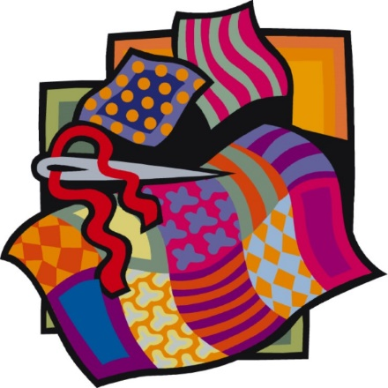

***The Third Saturday in March Every Year!*   
*National Quilting Day - Celebrate!!***

Our guild meeting happens to be the same day as National Quilting Day.  Read more about this on the National Quilting Association website <http://www.nqaquilts.org/nqd/>  .  I would like to suggest that a way to celebrate this day is to show appreciation for Grace Community Church for allowing us to use their facility by helping stock their Essentials Pantry.  As you enter the door, there has been a large basket for donations.  Wouldn’t it be nice if our members brought in articles on 3/21 for this?  The list of non-food items requested are:  toilet paper, dish soap, SOS pads, paper towels, facial tissue, napkins, sandwich bags, coffee filters, laundry soap, all purpose cleaner, hand & body soap/lotion, shampoo, toothpaste, dental floss, toothbrushes, sun screen, deodorant.  Food stamps don’t cover these items.  A nice way to show ‘caring and sharing’.

 Pat Clark

**Congratulations to Marion Warneke the winner of the Block of the Month at the January meeting**

**Newsletter**

The newsletter is published September to June. Any items, articles, and/or notices for the membership should be sent to the newsletter chair by the Friday following the monthly meeting.

Peggy Smith at ps.wiltwyckquilters@gmail.com

**Quilting in New Zealand**

Karen Eckmeier’s post at American Quilters’ blog details her adventure in quilting while teaching in New Zealand. Ms. Eckmeier was an instructor at the Quilt Symposium Manawatu in Palmerston North, New Zealand. Take a few moments and enjoy the photos of the beautiful country, people and sunshine.

[http://www.quiltviews.com/new-zealand-following-the-koru](http://www.quiltviews.com/new-zealand-following-the-koru%20)

**Quilts for Africa**

We will be collecting quilts at the May and June meetings for Africa. The quilts may be any color, any design, and any size. Shirley Swenson is collecting the quilts and will give them to Dr. Shirley Jones for the University of Albany students’ summer trip to Africa.

**Presidents Block**

Attached is the pattern for Anita’s thank you block. Please use unbleached muslin for the signature area and two of your scraps for the corners. The direction indicate there will be two triangle sets left over, share them with a friend if you like. HINT: make the template from freezer paper, press to muslin, sign name and any other message—town, date joined etc. Cut out, peel off paper and sew to triangles.

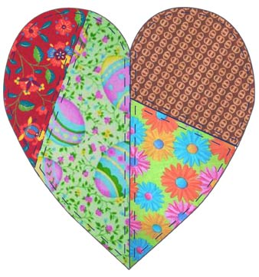Please return to Lesley Grey at May meeting. If you have any questions, please contact Lesley Grey.

**Be sure to check the size of the template. The size may have changed due to copying the pattern.**

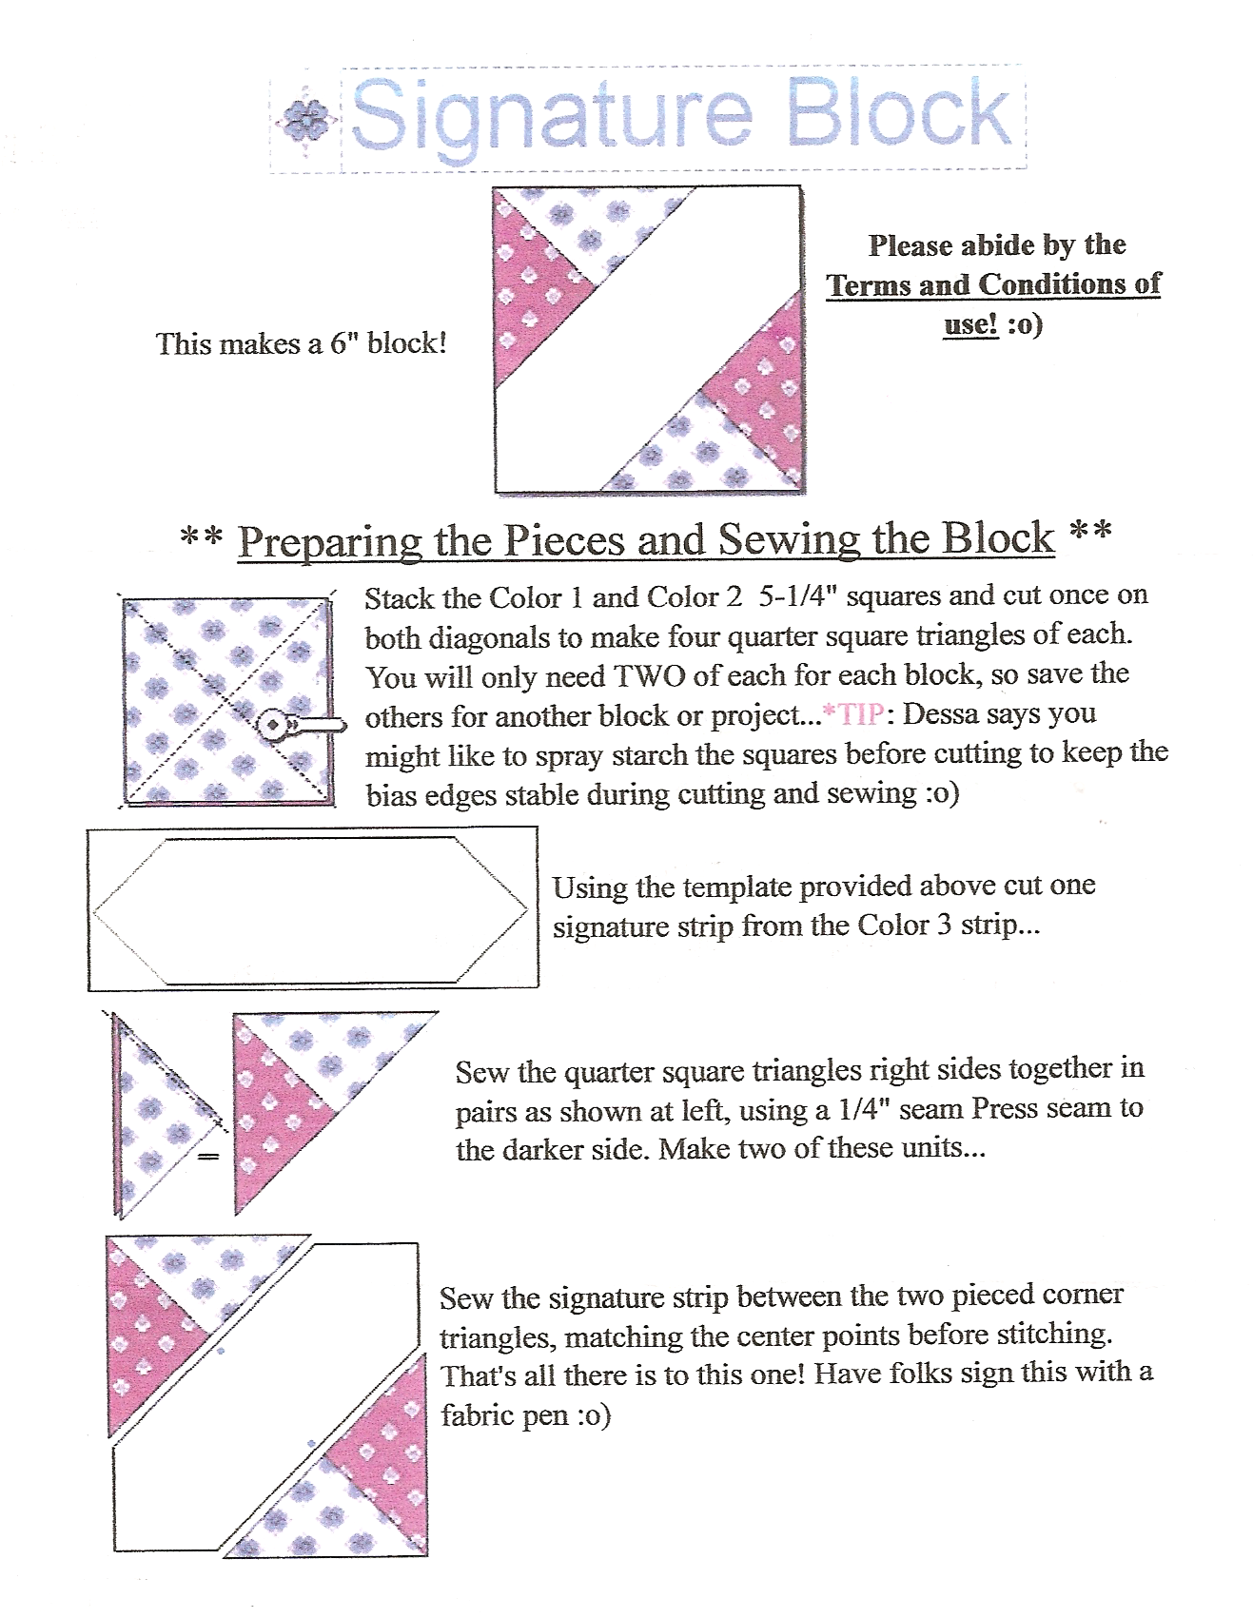

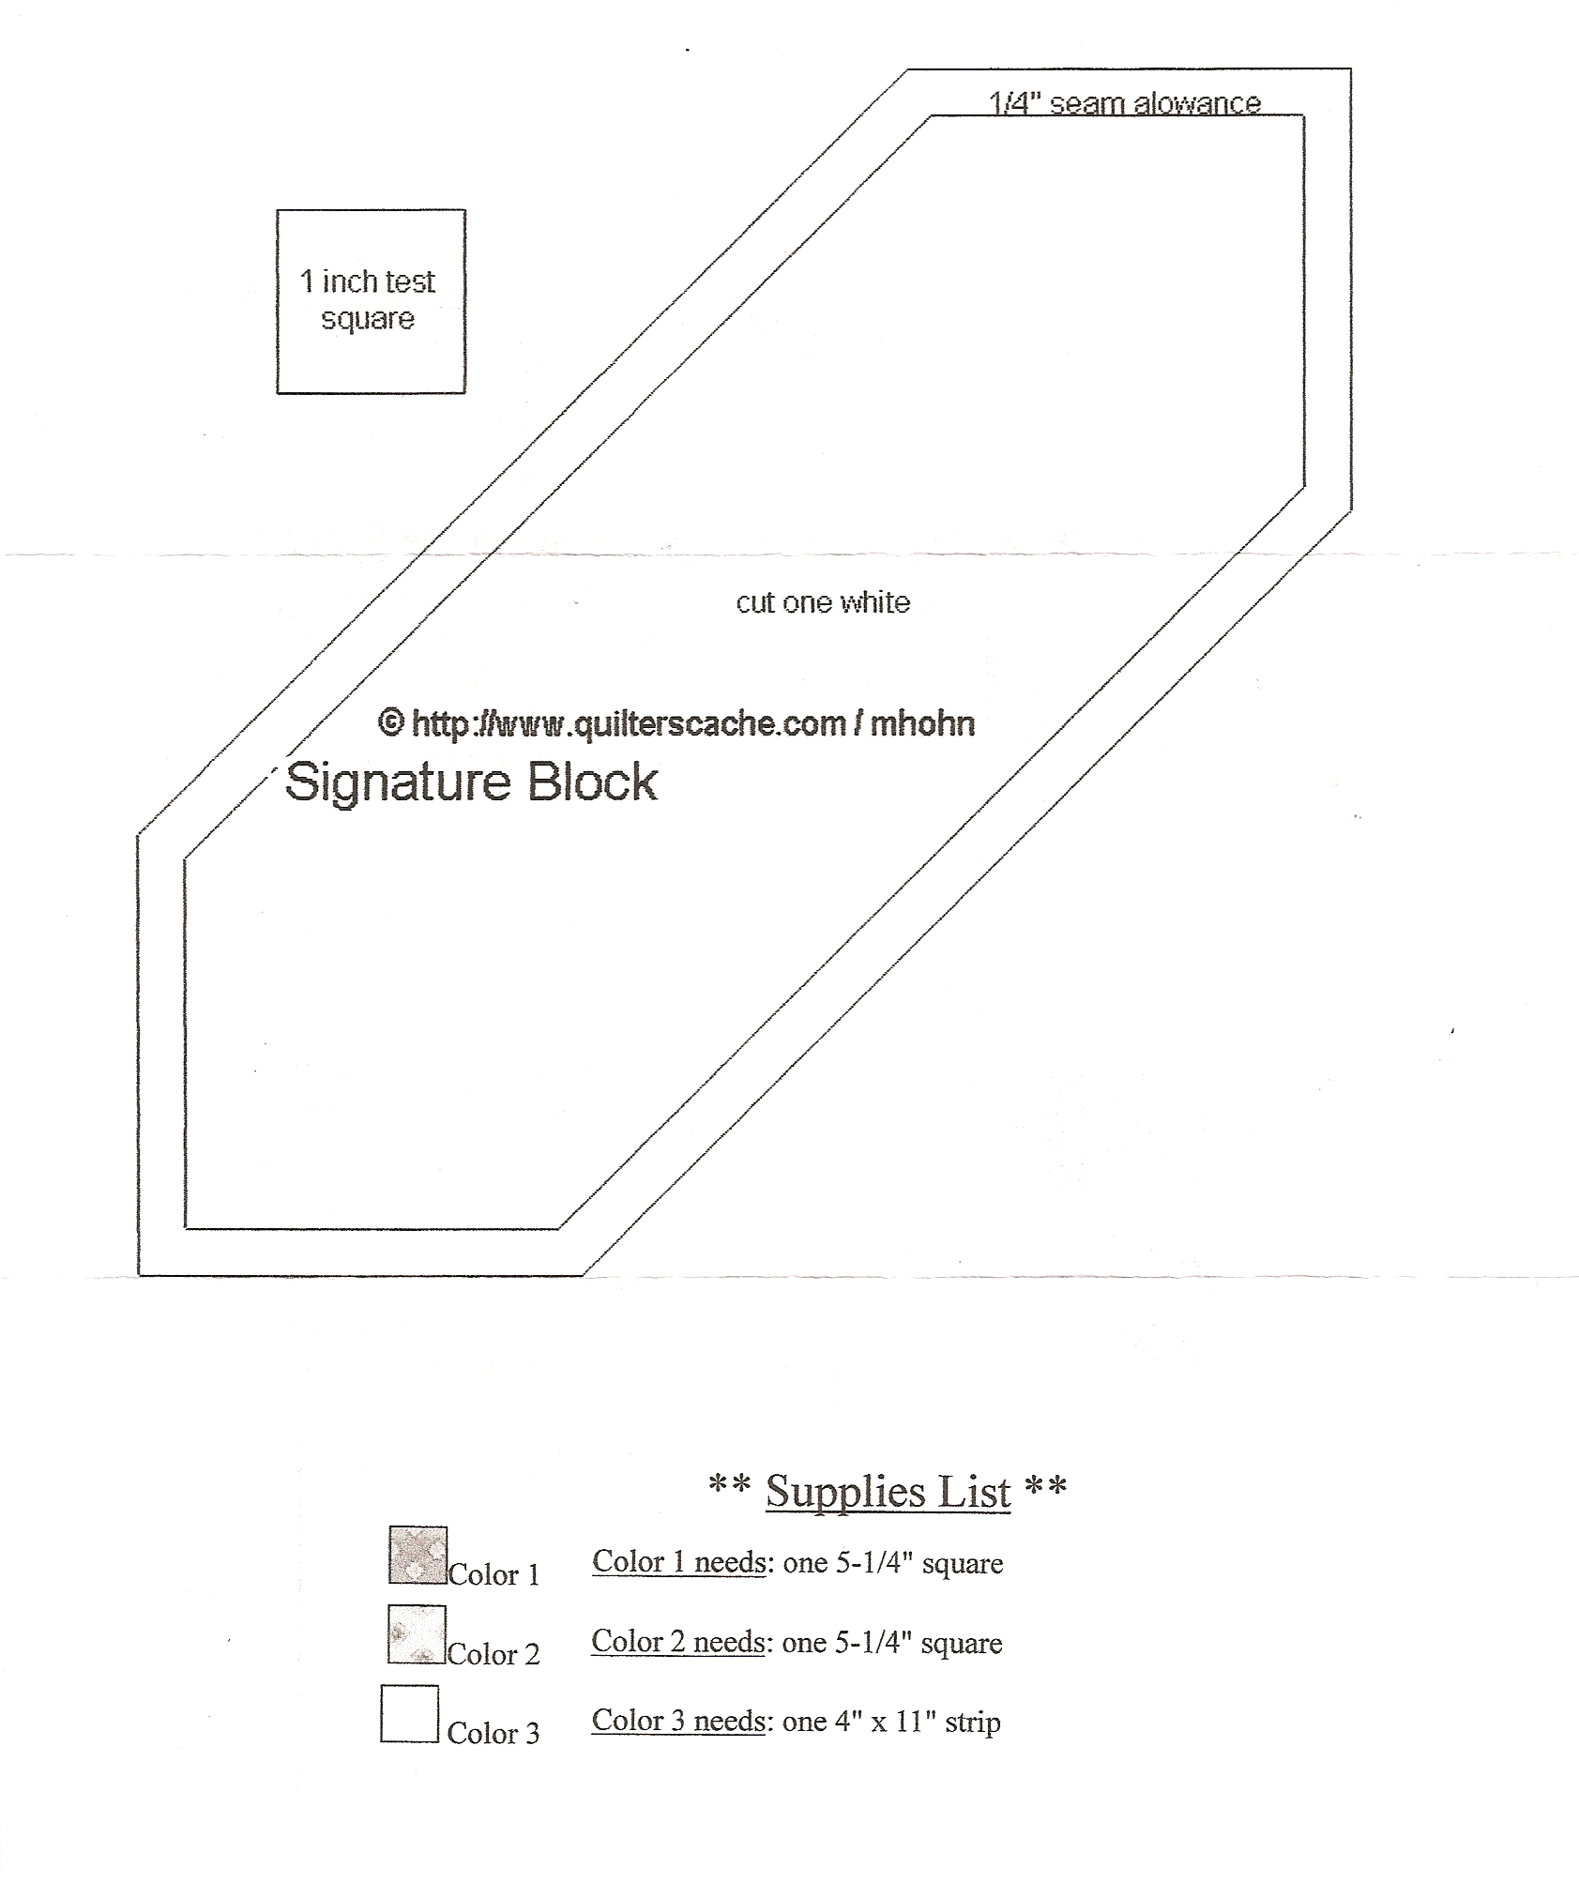

**WILTWYCK QUITLERS’ GUILD**

**PO BOX 3731**

**KINGSTON NY 12402**